Chapter 12
Real-time Interactive AR for Cognitive Learning
Priyanka Jain¹ Nivedita Bhirud² Subhash Tatale³ Abhishek Kale⁴ Mayank Bhale⁵ Aakanksha Hajare⁶ N K Jain⁷

1Associate Director, Artificial Intelligence Group, C-DAC Delhi India
^{2,3} Assistant Professor, Department of Computer Engineering, VIIT, Pune, India, subhash.tatale@viit.ac.in*
^{4,5,6} Students, Department of Computer Engineering, VIIT, Pune, India
⁷ Senior Director, Artificial Intelligence Group, C-DAC Delhi India
Abstract. A dynamic simulation of a behavior-rich interactive 3D virtual environment supports cognitive learning. The examples of pedagogies such as constructivist learning, situated learning, game-based learning, inquiry-based learning can be reinforced by Augmented Reality (AR). Based on Piaget's constructive theory of cognitive learning [1] through with the adjoining atmosphere-play, visualization and animation, we are proposing visual and linguistic analytics to promote cognitive development by effectively using AR. We have set the hypothesis of our proposed work that if the data is in visual form, it may be easy to comprehend for a person having linguistic learning difficulties.
Prior to this proposed work, we have studied, designed and developed a research work Preksha –A Hindi Text Visualizer; an Automatic Text Visualizer (ATV) for the Hindi language [14]. The Preksha architecture has a user interface to take language input and to produce a 3D virtual environment. The whole process is supported by a structured resource repository. As an initial concept, the Preksha work is only limited to a simple text-to-scene conversation system with the responsibility of understanding the input text and transforming into a 3D scene using computational process. As a contribution in this proposed research, the extended work is carried out with the support of interactive Augmented Reality (AR) mainly for user’s innovativeness and their sustainable behaviors relationship. Along with the contributed work in run-time generation via AR technology, our presented research got extension with cloud porting, computer vision, interactive virtual assistance and voice support pertaining to an important domain of mental heal support. The advancement in AR technology has led us in the creation of intelligent live Avatar (3D character) in the immersive real world as an ally of the end-user. This avatar comprehends and performs actions based on linguistic instruction using Natural Language Processing (NLP) in text and speech using Automatic Speech Recognition (ASR) technology. With the easy and popular availability of powerful hand-held devices, we can bring object recognition to the AR platform, where users can manipulate and identify recognized necessary objects by using their voice input.
The proposed work is multidisciplinary research covering the domains of clinical study, computational engines, run-time interactive user interface and software integration with a ready to deployable solution in association of throughout proof-of-principles. The considered Hindi language in this research is morphologically richer and has a free word order that makes it more complex [2] for computational language processing. To the best of the knowledge of the authors, this is the only published work of the ATV system for an Indian Language, viz. Hindi. Here, the considered user domain is for cognitive learning. Visualization may help in decreasing the cognitive load of a person who has difficulties in comprehension e.g., Dyslexia. The research is beneficial in learning a language and spatial aspects, especially for the rehabilitation of a person with some delayed development.
Keywords. Cognitive learning, Augmented Reality (AR), NLU (Natural Language Understanding), NLP (Natural Language Processing), Automatic text Visualizer (ATV).
  - Introduction
Cognitive-communication abilities are human thought processes like orientation, attention, memory, problem-solving, and executive function. It allows functioning successfully and interacting meaningfully with each other. It can be used in human behaviour simulation with the advancement in the current technology. By combining simulated elements with a person’s real environment; the proposed work will be able to face complex issues related to cognitive rehabilitation. Advancement in new technologies will help them to learn a language with visual cognition in a much simpler way.
Our proposed work on special education based on cognitive behavioural therapy (CBT), provides an effective and trustworthy basis for cognitive learning through visualization. As an extension of our previous work [17], this research has an objective to produce an interactive animated behaviour-rich web-based 3D immersive rich environment, based on the user’s input in language form. It proposes a grounding that the visual data has higher bandwidth, and it is easier to comprehend by a person with Specific Learning Difficulties (SLD) or Autism Spectrum Disorder (ASD) [10][12][13] [19-20]. The proposed approach is to understand human language and create a dynamic 3D AR environment. Learning-disabled children with autism or mental retardation require both quantity and quality education, e.g., Dyslexia. Students suffering from this disorder find it difficult to decode new words or break them down to perceive information [30] [31]. The use of visual communication has increased for expression as objects in the form of the pictures, signs & symbols, gestures, postures are easier to understand. Also, the visualization approach can serve as a universal language where smooth communication is needed by many different people who speak different dialects and have different cultures in a country like India. The proposed work may enable the end-user to interact with virtual objects/artifacts in his/her real environmental world with the availability of AR. The major contribution in this key technology is by the understanding of human language in real-time and performing the set of actions. Significant advancements in NLP and linguistic analysis have paved the way for computers to understand more complex Language phrases and carry out actions as instructed.
Mental imagery e.g., Cognitive visualization is the ability to construct, manipulate, and interpret images in the mind. It has a greater impact to perceive the phenomenon in virtual environments. Using it through Augmented Reality adds a richer experience where learners can actively pursue their knowledge needs. Therefore, we focus on modelling an easy-to-use and interactive virtual environment specific to the Indian Scenario. It is an immediately deployable solution with large commercial potential and a direct impact on the vision of social welfare. We have worked on this problem statement after understanding the user requirements related to special education. To have a better and deeper understanding, we had consultancy with domains experts and end-user agencies who are associated with mental health rehabilitation issues. With their appreciation for our initiative, we got assurance to get their support as a domain expert in the planning and designing the pedagogy. The domain experts and caretaker of patients would support us in assessment and evaluation of the project outcome by providing access to real user of the application. We are now intending to build interactive AR animations to help children to visualize objects in the real world.
The paper is organized in the sections as Section 1.2 presents the literature survey for the language, vision, and AR technologies. With the language erudition and learning paradigm, Section 1.3 talks about the previous work on the subject. Our design goal and an in-stages visual plan are described in detail with clear specimens in Section 1.4. The results, evaluation, and research findings are discussed in Section 1.5. Section 1.6 provides the conclusion with a discussion on the future scope of research work.
  - Related Work
AR and Virtual Reality (VR) technologies have shown tremendous growth with the speed at which the technology is growing. This literature survey shows work especially in the field of AR & VR for educational purposes. We present the critical review with the perception of shortcoming of existing work and contribution by our proposed unique approach that is linguistic analysis for visual cognition. Human behaviour and actions by means of associated object management or manipulation can be described with the use of language, as discussed by Guerra-Filho and Aloimonos[8]. According to Gupta [9], linguistic concepts are easy to address the problems related to Computer Vision (CV) and related work using Lexical semantics. A scene contains information that is comparable or like a language which is provided by Sadeghi and Farhadi [27]. It links scene or artifacts to words, preferably nouns, the activities to action verbs, objects, features or attributes to adjectives and the prepositions are the relationship between objects. Zhao and Grosky[40] bridged the semantic gap between visual data like pixels or contours to language data like words or sentences. The cognitive theory for studying using multimedia has two different knowledge systems: a visual knowledge and verbal knowledge. Funge[4] has mentioned a cognitive modelling application in his automated cinematography using advanced character animation. Singhal and Zyda[29] have represented the avatars of online users in the virtual world in their work. Klcaslan[23] has proposed a concept that uses NLP for children with mind blindness or mental retardation. Schank[28] and Gaddis [5] have proposed a majority of work on duplicating a real environment along with its physical models and interaction between objects. To control the parts of animated humans or animals at the graphical level, joint transformations (for parts like limbs) or surface deformations (for parts like face) is used. Motion synthesis for animated or digital characters is commonly classified between real-time and off-line animation generation. The algorithms that were initially considered for off-line animations moderately become practical in run-time virtual environments because the speed of processors continues to increase cautiously.
Research in designing a complete independent, mutually interactive, artificial 3D model has also been on the heights. Tu and Terzopoulos[39] implemented a realistic simulation of virtual fishes with their autonomy, simple behaviours, motion generation and simulated approach. A navigation system was proposed by Noser [25]on vision, memory and learning for virtual or digital characters. Researchers at Georgia Tech. C. Brogan and J. K. Hodgins [3] has merged assumptions with physically based behaviours for assuming human athletics by designing human running in a 3D environment.
While most research are done in Virtual Reality to make a 3D environment to foster cognitive learning, they often miss out on the point of AR, i.e., inducing only 3D models into the real-world giving the user a more interactive experience. In our research, we improve upon the idea of visual learning by injecting live 3D model animations in the real world captured by our mobile device camera and interacting with it using voice commands. AR is the experience of interaction between the models in the user’s real environment and the objects generated by computer graphics. It adds the digital or animated components in the real world with a feeling of real-life experience as a 3D model of a pet animal ‘Dog’ in the user’s room is shown in figure 1.
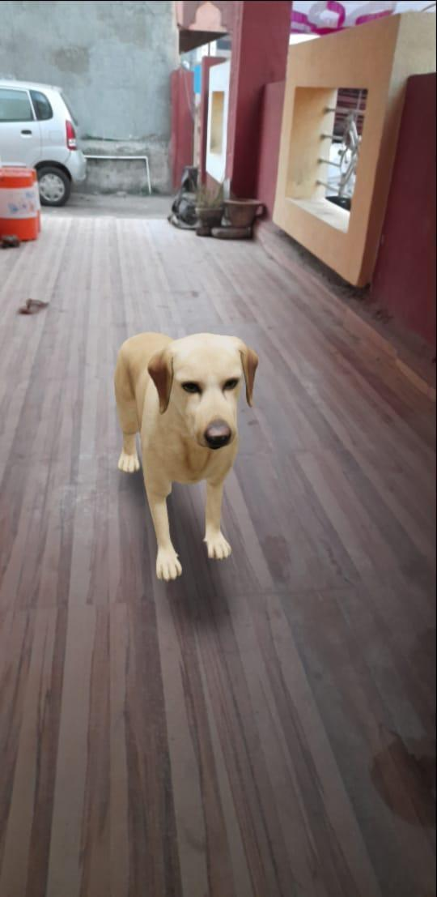
Figure 1: 3D model of a dog in AR Scene
For relevant and correct content, AR uses computer vision, plane-detection, and depth tracking, that is, calculating the distance from the object. AR allows the camera and microphone to collect data and process it to get the desired output by the user. AR does not create a virtual environment like VR, but it plays with the existing environment. AR is hugely accessible by users in the growing smartphone market being mobile and personal. AR has its practical applications in almost all domains like automobile, tourism, finance, education, simulation, etc.
  - Need and Motivation
Today, the world focuses on cognitive Learning, i.e., more constructive use of the brain and learning which is active, effective, and long-lasting. It has been understood that traditional teaching methods are not as effective and sometimes heavily rely on rot learning. However, in recent studies, it is found that technology can help develop cognitive learning among students. The proposed work emphasizes this idea and presents a way to use the latest advancements in AR to facilitate cognitive learning by audio and visual means. Linguistic and Visual Analytics can be understood well in Figure 2.
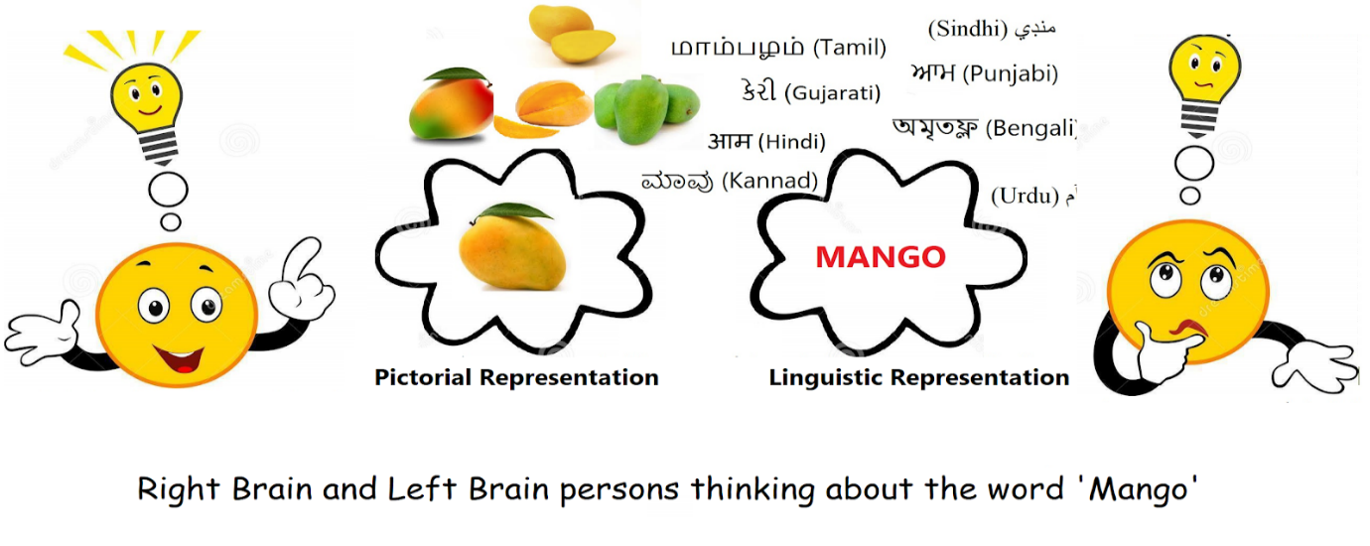
Figure 2: Linguistic and Visual Analytics
We have implemented Preksha: A Hindi Text Visualizer [17]. The architecture of Preksha has a good balancing of cohesion and coupling with its modular components. It takes input from the user and produces a dynamic 3D virtual environment, as specified in the input sentence. Figure 3 shows the generated out of the Preksha system for input text: “कांफ्रेंस टेबल पर सफेद लैपटॉप, सिल्वर लैपटॉप और सीडी हैं. कमरे में ब्लैक-बोर्ड हैं. एक कोने में पोडियम के-पीछे महिला टीचर है. पोडियम पर माइक के-पास पेंसिलस्टैंड और दो पेन-ड्राइव हैं. सफेद लैपटॉप के-आगे किताबों पर चाय की प्याली है.” The English text corresponding to the Hindi text is “There are white laptop, silver laptop, and CDs on the conference table. The room has a blackboard. There is a female teacher in the corner behind the podium. Near the mic on the podium, there is a pencil stand and two pen drives. There are cups of tea on the books ahead of the white laptop.”
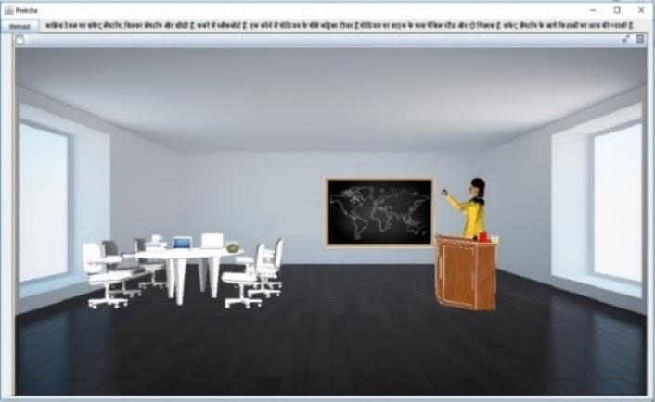
Figure 3: Output generated by Preksha
In the current proposed work, the research outcome is achieved using a sophisticated NLP engine in Hindi Language processing, a knowledge processor, and a dynamic scene generator. First, Language engine pre-processes the text and extracts part-of-speech (PoS) hybrid layered approach. It is done using syntactic analysis using two parsers namely Tree adjoining grammar (TAG) Parser and Context free grammar (CFG) Parser. The processing of a sentence includes morph analyser, POS tagging, and syntactic parsing. The output of the language engine is in standard XML format, as mentioned in Jain [18].
The next step includes understanding the NLP engine’s outcome. It extracts the scene-knowledge and prepares a parsed XML file. The parsed XML extracts and prepares another XML for knowledge representation (KR) as an output of the second Engine. The KR is collative information of three components. A Meta information of document as MInfo, second is Environmental information of the scene as EnvInfo and the third is Entity information of entire 3D Models objects EntInfo.In the last step of the dynamic scene generation [11], it selects appropriate 3D objects based on their attributes and suitable background. By conducting a subjective evaluation using an online survey, the Preksha system is evaluated on 10,220 user responses for the parameters of Intelligibility and Fidelity. Here, Preksha is evaluated as Very Intelligible by getting a 3.02 /4 score and Fairly Accurate on obtaining a 2.91 /4 score as discussed in detail in our previous book chapter [21].
  - Proposed Work
The architecture of the proposed work is multidisciplinary research covering the domains of a clinical study, computational engines, and software integration with a ready to deployable end-to-end proof-of-concept. The end-user operates the software through mobile or hand-held devices, whereas the computational process takes place at the server. Here, we provide a design of overall work and components for visual and linguistic analytic as a cognitive aid. Cloud platform promises for scalability of Cloud services that are used to keep the client system free from unnecessary clutters and reduce the system computation resources by processing data on servers. Audio and visual tracking supports us to provide interactive animations. The project exploits the capabilities of the popular game engine Unity3D [36] to build AR Scene. Major software development kits used are AR Core, AR Foundation [33], and Vuforia Engine [16].Backed-up by a robust structured resource repository, the basic system consists of 3 main components: (a) Language Input: text input or ASR for converting speech into text by STT APIs, (b) Language Processing engine using NLP on text to generate animated environment by understanding its meaning, (c) AR Scene Engine to render rich immersive environment with 3D objects in the mobile scene as shown in Figure 4.
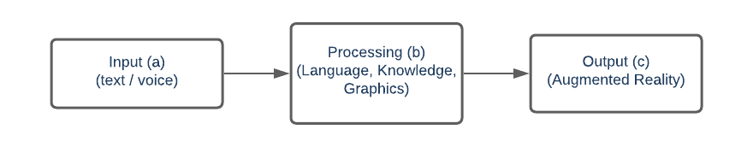
Figure 4: Major components
Figure 5 shows the overall architecture flow of the proposed research. The input of the system is in language command that is in text or speech form through Android OS based mobile phone or any hand-held device. The end-user of the system uses the interface ‘UIT’ of the proposed mobile app to enter text input. For providing speech input he uses the microphone of the device.
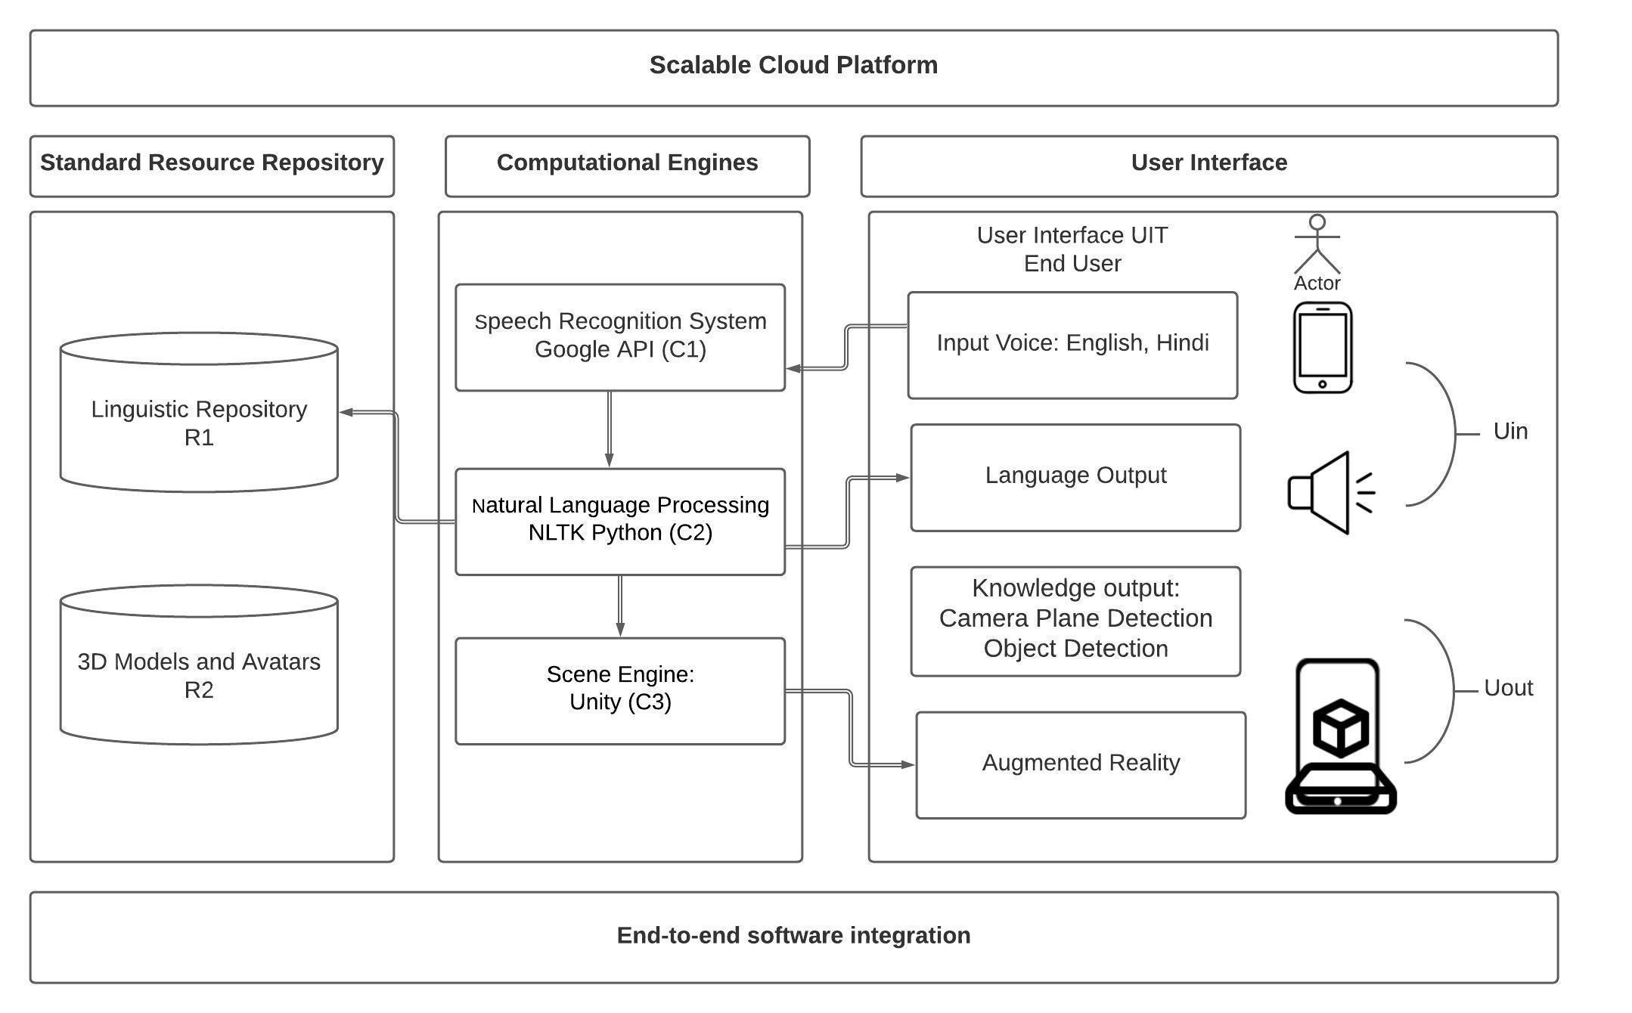
Figure 5: Proposed architecture
It consists of two resource repositories: Linguistic repository R1 and 3D Artifact repository R2. Three major computational engines are used here namely Speech recognition engine as C1, NLP engine as C2 and Scene Engine as C3. We describe the detailed functioning in subsequent sections after explaining their process flow of work.

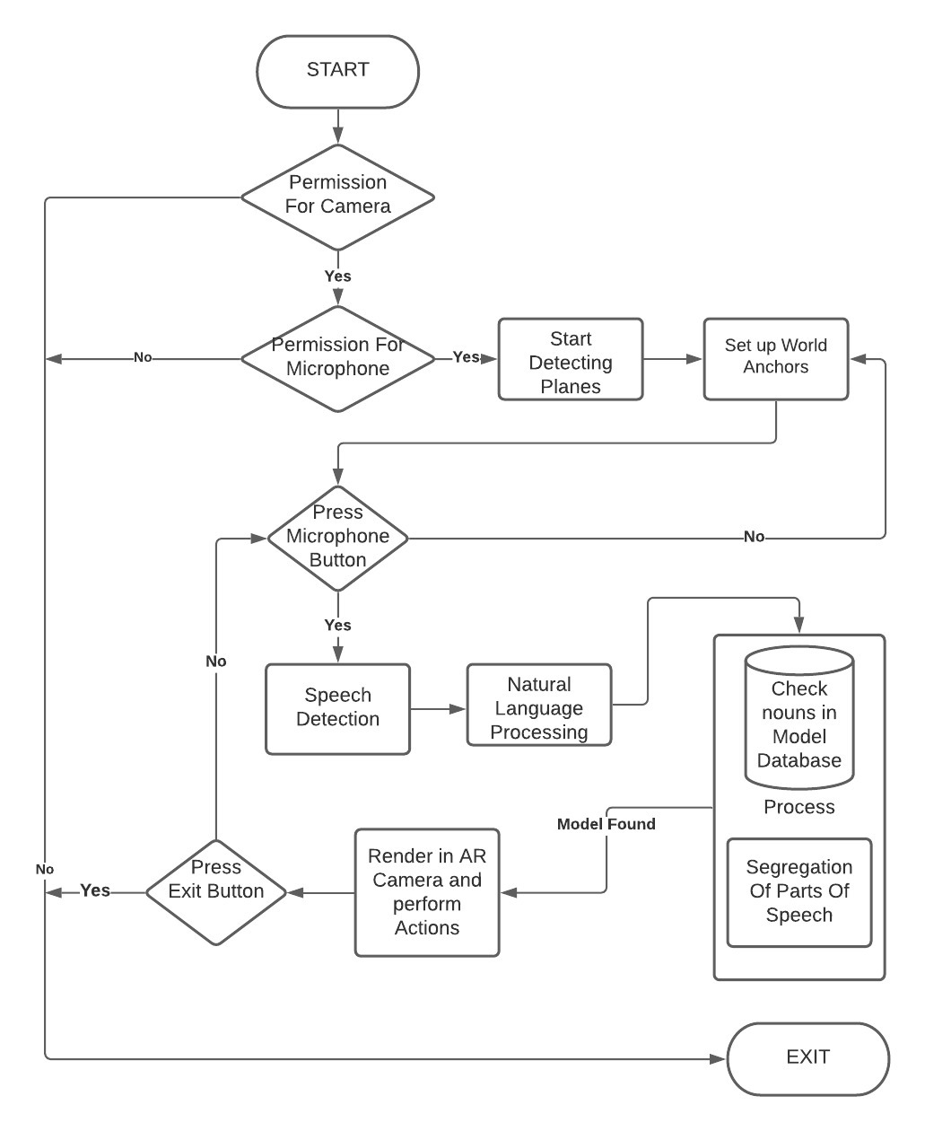
Figure 6: Flow Diagram of the Proposed System
Having investigated after receiving the voice input, the engine sends data to different modules. Computational engine speech recognition indicated as C1 (Voice recognition System) receives the voice input from the device camera component (Camera Plane Detection). Camera Plane Detection constantly keeps track of planes, point clouds, and tagged objects. The received audio is fragmented into actual identified words for further processing of Language analysis by computational engine C2 (Natural Language Processing). The C2 NLP engine majorly does the shallow parsing using pre-processing and PoS Tagger using R1(Linguistic repository). The processed text helps in further operations like the identification of objects and their dependency relation. The engine then checks the availability of models in the database system (R2 - Avatars and Models repository). If the 3D models are available, it is retrieved, and the corresponding animation is performed in the AR Scene. In case of user’s not performable input, an appropriate message prompts on the scene with appropriate message. Finally, all modules are combined (C3- Rendering Objects and running Scripts) and rendered onto the mobile device. Figure 6 shows the flow diagram of the proposed system. With the parallel processing of visual data, the application will also respond to user interaction with voice commands. It will retrieve the required information from the database located on the cloud. The cloud component is used to reduce the size and computation of the application of mobile devices which have limited resources.
The detailed architecture is described in the following sections. The cloud integration is given in Section 1.4.1. Section 1.4.2 discusses linguistic analysis and its processing. The speech is broken down and various parts of it are analysed including separation of noun, verb, pronoun, and preposition. Once done, nouns are then searched or generated virtually on the screen and the action is performed over it. Section 1.4.3 highlights the visual computing approach in application and sentence spoken into the system and its analysis and conversion of speech to text are explained in section 1.4.4. Section 1.4.5 explains Engines and SDKs required for building the application and 1.4.6 explains the cloud integration required for all modules to run an application at run time.
Scalable Cloud integration
An efficient software integration enhances the performance of any application for its robustness and scalability. While there are many ways to implement AR applications, Unity 3D software stands out in its efficiency to handle complex data generated in AR scenes and handling the output with precision. The integrated AR features with the latest and cross-platform technologies such as AR Foundation makes the application portable for multiple devices. The development in.NET [32] environment helps in efficiently handling the hardware letting us focus more on the productivity of the application than the compatibility. Unity 3D is a popular game engine that has expanded its usability in Mixed Reality environments. Therefore, Unity 3D is used in the development of the proposed system. Along with it, we also have used AR Foundation, ARCore, and Unity Barracuda Engine for AR Scene Generation and Object Tracking.
It is not feasible to use all these features in a single standalone app due to the size of the 3D avatars and the NLP engine. If such features are bundled in one app, the system can meet hardware issues. To avoid such run-time issues, the databases have been stored on the cloud and can download this on-demand when required. This will keep the app-based proposed system free from excessive use of unnecessary data and supports the minimal use of resources.
Today, with the advancement in 4G technology, we can download the 3D avatars from the web database and generate them in our scene with minimum lag. The popular cloud engines in the market like Google Cloud and AWS provide database storage for avatars and database storage on the cloud as shown in the R2 module of the architectural diagram. The Language Processing and the 3D module generation will need cloud integration and for that, the device will need to be connected to the internet all the time while using this app.
Input Interface
User-interfaces are the most important aspect of usability when it comes to any user-oriented application. Communication by mobile technology like Smartphones and tablet PCs have revolutionized our life. This also works as an Assistive Technology (AT) market for people with disabilities. However, the computational engines will be residing on Servers, the end product of the system would be an android based mobile apps. These can be used by persons, their parents, and educators as a part of learning activities.
The app developed has a very simplistic UI with only a microphone button on top of the Scene. Once tapped, the Google Voice Recognition API [7] opens. On the provided interface, the end-user needs to provide voice input. The API sends the voice input to Google Server to process and returns the speech in text format. All this process is performed on the internet in the back end. Hence the proposed system needs to be connected to the internet to use this feature. The API can be used on any device capable of connecting to Google Servers. For the proposed system, we have used a ready-made Plugin of Speech Recognition for Unity Android [6]. Figure 7 shows the pseudo-code for the Android Operating System.
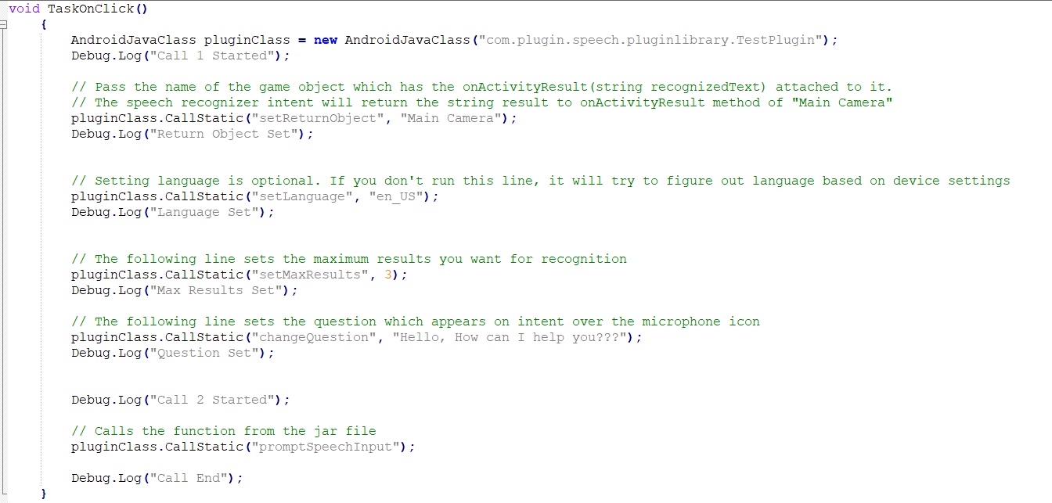
Figure 7: Pseudo-code for Android Application System

The Android Java Class captures the audio and prepares the data to be sent to Google servers to decipher the words. In figure 7, we have set the language to English – US. We can also set the language for native Indian Language support viz Hindi. The result is received in another script where it is stored as a string and is shown on the screen in preview builds. Figure 8 shows the script for storing the result.

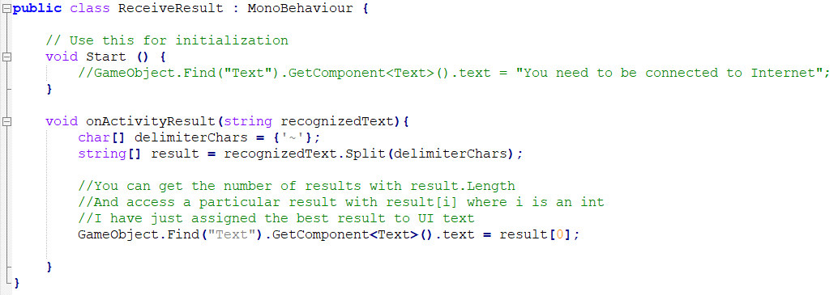
Figure 8: Script for storing the result

The app then forwards the received text to the language processor as shown in the C2 module of the architectural diagram and explained in part 4.3 in the paper.
Computational Engines
Computational engines are the components accountable to offer virtual surroundings as a User Experience (UX) after processing the models. The structure of the proposed engine includes primary subsequent processing steps: Language processing and Knowledge processing.
Language Processing Engine
The language considered in the proposed work is Hindi, that is a morphological rich free word order language. It is a relatively challenging and complex task as a single piece of facts may be offered in more than one syntactic construction to ambiguous semantics. In the case of the goal of visualization, this example turns into critical. Based on the grasping power of the man or machine, the same piece of facts may be visualized in diverse forms. Therefore, an ATV machine with many-to-many relation of textual content and scene needs a sturdy base for language processing engine. The language engine is familiar with the entered language textual content via means of syntactic evaluation within the first step. The Natural Language Toolkit, or more commonly NLTK [24], is an NLP library that contains collections or packages to make the machine understand human language and extract its meaning to reply with an appropriate answer. Python [26] programming language is used for writing NLP scripts. The input text (query) is processed on the NLP engine(C2) as shown in figure 5. Language processing is classified into parts (a) Pre-parser processing and (b) Parsing.
Its methods enter textual content in a sentence-by-sentence mode. As mentioned in Jain [18], the processing of a sentence consists of morph analyzer, PoS tagging, and syntactic parsing. The pre-parser processing component starts the language processing to prepare the source text for the normalization process of the parsing. It uses morphological analyzer components like tokenizer, stemmers and PoS tagger. NLTK library is used for the purpose of the same, the pseudo-code for tokenization is presented in Figure 9.

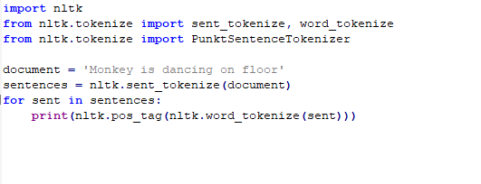

Figure 9: Pseudocode for tokenization
Input Text: “कमरे में टेबल पर गमले के पास फोन रखा है.”
Tokenized output : [कमरे] [में] [टेबल] [पर] [गमले] [के-पास] [फोन] [रखा-है] [.]

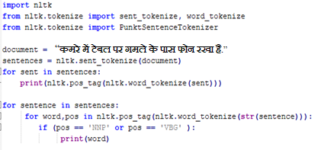
Figure 10: Pseudocode for PoS tagging

The pseudo-code using NLTK library for PoS tagging is presented in Figure 10. PoS tagged output: कमरे(NNP) में(PSP) टेबल(NN) पर(PSP) गमले(NN) के-पास(PSP) फोन(NN) रखा-है(VBG)’

Here, the key entities are extracted from the PoS tagged output and the code snippet provides the output: Monkey (NNP) and Dancing (VBG). The syntactic parsing of an input sentence drives a dependency relation tree with the identity of semantic arguments at the side of their rules and motion verbs. This tree inherits dependency members of the family and linguistic functions primarily based totally on linguistic context. A linguistic knowledge repository (R1) is ready as in step with the rule-primarily based engine system. It is a series of assets required for the computational model. These assets into parts: grammatical lexicons and repository of linguistic rule base. The computational processing of the scene engine is supported through a scene useful resource repository. A generated entire scene surroundings is the composition of all viable facts obtained from the user's entered textual content. This is implemented in the usage of TAG Parser and CFG Parser as stated in Jain [16] and Jain [22] respectively, as shown in Figure 11. It helps to identify semantic arguments like subject and predicate at the side of their dependency relations.

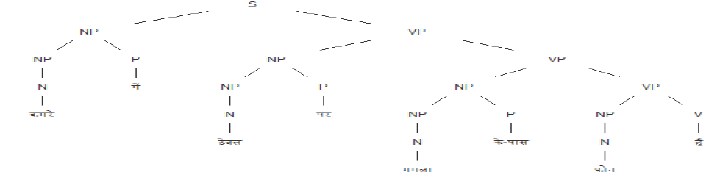
Figure 11: TAG Parsing output on given example sentence

Knowledge Processing
The current Knowledge processing engine is the extension of our earlier work Preksha [17]. Knowledge Extraction (KE) and Knowledge Representation (KR) are the main components of the knowledge engine. The KE engine is used to examine the factors of parsed derivation in a standard XML. Scene knowledge is taken out from the parsed tree, by spotting the semantic and dependency connection of the nodes. By spotting semantic and dependency connection, scene knowledge is taken out from parsed tree. The entered textual content is a set of Text Clausal (TC). Local Word Groups (LWG) which includes TC and one or more semantically associated textual content. An Entity is a bit of 3-tuple records correlated to physically bodily objects. Using the systems from the language parsed output, the task of the knowledge engine can be done while resolving anaphora and other co-references. The postposition is phrases for prepositions in Hindi.पूवर्सगर्, िवभिक्, or सम्बन्धसूचकअव्यय that are greater complicated Jain [15] to address and to evaluate to pre-position phrases of English or comparable European languages. The premise of placement strategy is offered from these relations. The extracted knowledge which is processed for KR is saved in some other XML document layout that is the output of the knowledge engine.
Scene Knowledge consists of MInfo, EnvInfo, (EntInfo1, EntInfo2,....., EntInfop). The tag <Scene> contains the data about the XML file with the knowledge of an instance of digital surroundings. After MInfo of the XML file, the tag <Scene> incorporates sub-tags viz. <EnvInfo> and <SceneInfo>. The tag <EnvInfo> holds the surroundings statistics of the scene being rendered. It is part of entered textual input which is difficult to visualizable however is vital for enough knowledge transfer. The Tag <EntInfo>has sub-tags like <Background>and <Objects>tags. The <Objects> contains objects which refer to a physical unit and a 3D model in a scene. One example of <EntInfo> is an entire representation of a single item entity of a 3D model within the scene such as its attributes and relations. The Object Attribute Relation (OAR) version is used for <EntInfo> tag as mentioned by Wang[38]. In the OAR model, objects ‘O’, attributes ‘A’ and relations ‘R’ suit the manner of human cognition. It also can be defined as a triplet, that's OAR = (O, A, R). In the entered text, the noun entities are the objects ‘O’ for rendering as a 3D model within the virtual surroundings. The corresponding noun has its attribute ‘A’ as it is an adjective. The attribute ‘R’ is the relation among the objects. The <Objects> contains a subtag <Relation>to symbolize the relation call that is related to objects or parents. The item positioned in a virtual space gets its coordinates by<Position>tag.
We used Unity Game Engine that supports C# [36] language. UsingIronPython script, we can implement python scripts in C# programming language. PoS tag is used to extract the noun (object) and verb (action word) from a sentence. It further fetches the respective 3D character and action file from the repository and sends it over to the Unity Game Engine for the further rendering process.
Output interface
AR experiences can be built by ARCore of Google’s platform. which enables a hand-held device such as a mobile device to sense its environment, understand the world, and interact with information using different APIs. ARCore is available for both Android as well as IOS devices. It, therefore, supports cross-platform development. To integrate virtual content with the real world it has three key capabilities as seen through mobile.
- Environmental estimation to estimate the relative size and spatial location of surfaces, be it horizontal or vertical.
- Light estimation to estimate the Environment's current lighting conditions from the phone.
- Motion tracking in understanding and tracking its position relative to the world.
ARCore understands the position of the mobile device in the world and builds its understanding of objects around it. The motion tracking uses feature points in the scene and tracks its movement over time and combines it with a mobile device internal sensor such as an accelerometer to determine the phone’s orientation and position. It can also detect flat surfaces like floor,table-top and help estimate light and environmental conditions around it. This allows the end-user to place 3D models into our scene and look at it from every angle even if the camera of the phone points towards another direction briefly. The 3D models get anchored to the point we place them.
The most striking feature in today’s AR application is the ability of the application to identify objects around it in a spatial region. Unity originally used the TensorFlow [34] Sharp plug-in with their Machine Learning Toolkit, ML-Agents to serve an environment to train intelligent agents. These are not just useful to game developers but also for AI researchers. These can also be used to train and identify objects in the AR scene.
Initially, TensorFlow was used often to train image models and identify cats from dogs in Python. Now with powerful mobile devices, we can bring object recognition to the AR platform, where users can identify and recognize common objects such as tables and chairs. This will allow for far more seamless interaction between real and virtual objects. Unity also allows cross-platform development using the new Barracuda inference Engine [35]. Barracuda can run Neural Nets both on GPU and CPU. These can be used to load trained models in the AR scene to identify objects. Vuforia [38] engine also allows scanning a specific 3D object and then using it in AR Scene to recognize that particular object and perform the associated task with it.
A dataset of many 3D images of regular annotated objects such as ‘chairs’, ‘tables’, and ‘cars’ is trained using Neural Networks and the trained model is then loaded into the Barracuda Engine. Each frame of the scene is then chopped into several small frames and is compared with the trained knowledge to check if any object can be identified in the scene. Once detected, a small red box showing what the mobile device thinks the object in the frame can be and its probability is shown. With a simple tap, the plane beneath the red box gets tagged with the name of the object identified.

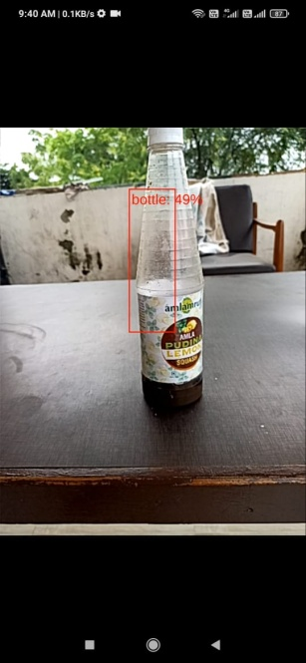
Figure 12:Object(Bottle) Detection.
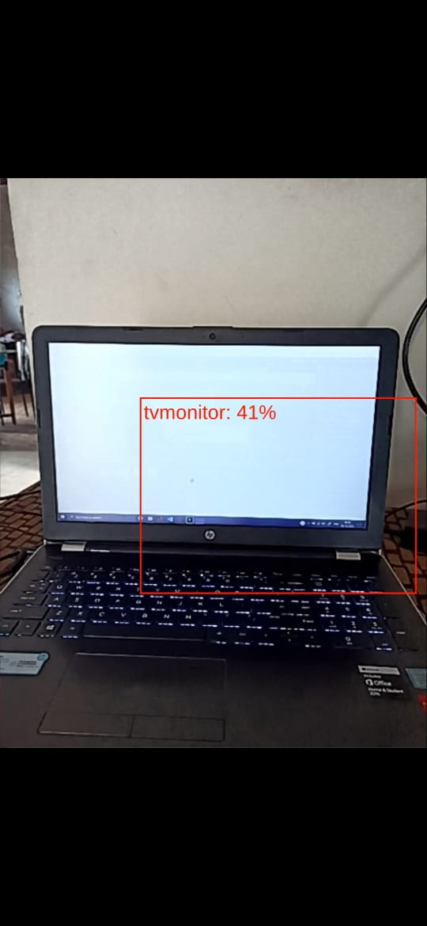
Figure 13: Object (TV Monitor) Detection.

In the background, the Unity Engine will keep on detecting planes and anchor points in the scene and understand the spatial organization of objects as shown in the architectural diagram. This will help to place the 3D avatars in the scene concerning the objects detected. An example is given in figure 12 and figure 13. As shown in the above figure the applications think that the object in figure 12 has a 49% probability of being a bottle. And the object in figure 13 has a 41% probability of being a tv monitor. The SDKs are still in Beta mode. The high-resolution video captured by phone makes the data-heavy process and occasionally may not recognize objects with 100% accuracy. However, it is just enough to tag the plane just beneath the identified objects with the same name

  - Result and future discussion
The outcome of the proposed work is in the form of a mobile app. It takes input from the user as a keyboard typed text and voice input using mobile’s mike. It processes the input text command and responds by generating the intended scene in AR World. Figure 14 presents two outputs generated by our system. Given an input in the text area of the application interface – “The boy is standing on the table”, the first image in Figure 14 (a) presents the virtual Avatar tagged as Boy (Human) performing a standing pose on the table. It takes care of identification of a real-world object “Table” and placing a 3D model of a boy from an annotated resource repository. The second image in Figure 14 (b) shows that by giving Hindi language input in the voice text form using mobile mike - “टेबलपरबिल्लीहै (A cat is on the table)”, the system identifies the spatial relation between these two objects and places the “बिल्ली (Cat)” on the “टेबल (Table)” as per the input command given by the user in a linguistic form.

Command by Keyboard input
(b) Command by Voice input

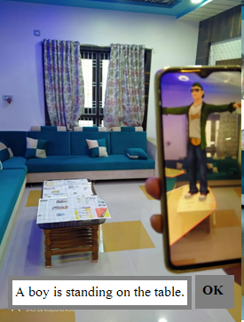
- Command by Keyboard input
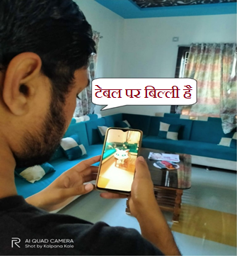
(b) Command by Voice input
Figure 14: AR model generated in the scene

This mobile app as the research outcome has been tested on mid-range devices with 6 GB Ram and MediTek G90T processor on Android Nougat with at least 3 GB of Ram and a dual-core processor with support for Google ARCore. The execution performance of the implemented system found pretty ‘OK’ with minimum lag in rendering the AR environment. After running many test cases with more complex scenes, it was found that although powerful, today's mobile devices are not as capable to identify objects in the real world in high resolution. The application runs perfectly with object detection in low resolution, however, misses the point of AR World. The application performs very best without object recognition and gives no lag whatsoever. However, with the advancement in technology every day, the day is not far to see handheld devices perform complex tasks like object detection.
We have worked to aid in capability enhancing to learn functional computational skills like money, time, capacity, weight, mass, length, distance along with reading, and writing aids. The system would handle simple language having references of physical objects used in day-to-day life like including animals, fruits, transports, and home appliances, etc. The narration should have references for shape, size, color, texture, position, distance, and spatial relations. Extendible to other Indian languages also, currently, this system would be capable of handling natural language in speech and textual form for code-mixing language (Hindi and English).

  - Conclusion
By providing the grounding effect of an immersive rich environment in mental imagery, we have shown that the proposed research work as an AR application is very useful especially for students who have difficulty understanding concepts or abstract data which are hard to understand or visualize. Persons with learning disabilities like dyslexia have difficulty learning and often learn very slowly. We have studied the importance of automatic text visualization and concluded that generating an enriched visual immersive environment by linguistic analysis may help the user to get the information comprehend easily. We have worked with its detailed plan by the consultancy of domain experts and provided an end-to-end solution fabricated with its detailed design and architecture for text to scene conversion process. All the internal components have been discussed in detail along with their technology and implementation aspects. Results have been presented and elaborated at depth.
Having accessed the research outcome in a form of an application on their hand-held devices, the user can now visualize and comprehend their complex machines to simpler items in their smartphone right as they work in the real world. With simple voice commands, the mobile device can now generate lifelike imagery. The project can be further extended with advanced animation and incorporating human gestures of the virtual 3D avatars. Fast network availability can make learning more meaningful, attractive, and challenging than traditional teaching by using the interactive, visual, and envelope features available in the virtual environment. Real-time interaction with virtual reality on smartphones for cognitive health needs more exploration. Also, it is necessary to investigate the effect and use of serious cognitive rehabilitation games that allow players to connect with other players using an Internet connection, especially with mobile devices.

References
[1]. Ackermann, E.: ‘Piaget’s Constructivism, Papert’s Constructionism: What’s the difference?’, https://learning.media.mit.edu/content/publications/EA.Piaget%20_%20Papert.pdf (Accessed on 10 Jn 2021)
[2]. Bharati, A., Sangal, R.: ‘Parsing free word order languages in the paninian framework’. In Proceedings of the 31st annual meeting of the Association for Computational Linguistics. pp. 105-111. Association for Computational Linguistics. Columbus, Ohio. 1993.
[3]. Brogan, D. C. and Hodgins, J. C.: (1995) ‘Group behaviours for systems with significant dynamics’. In Proceedings of IEEE/RSJ International Conference on Intelligent Robots and Systems, pp. 528–53
[4]. Funge, J., Tu, X., Terzopoulos, D.: (1999) ‘Cognitive Modeling: Knowledge Reasoning Planning intelligent characters’. In Proceedings of the 26th annual conference on Computer graphics and interactive techniques SIGGRAPH 1999, Los Angeles, CA., Annual Conference Series, ACM SIGGRAPH. pp. 2938. DOI:10.1145/311535.311538
[5]. Gaddis, T.: (1998) ‘Virtual reality in the school’. In Virtual reality and Education laboratory, East Carolina UniversityDOIhttp://doi.org/10.1089/109493103322278772
[6]. Github, Unity Android STT, https://github.com/gsssrao/UnityAndroidSpeechRecognition [Accessed: Oct 14, 2020
[7]. Google Cloud, Speech-to-text, https://cloud.google.com/speech-to-text [Accessed: Nov. 3, 2020
[8]. Guerra-Filho, G., and Aloimonos, Y.: (2007) ‘A language for human action’. Computer, Volume 40, Issue 5, pp. 4251.
[9]. Gupta, A.: (2009) ‘Beyond nouns and verbs. Ph. D. Thesis, University of Maryland.
[10]. Jain P, Bhavsar RP, Lele A, Kumar A, Pawar BP, Darbari H (2017a) Knowledge acquisition for automatic text visualization. In: Proceedings of national conference on advances in computing NCAC-2017
[11]. Jain P, Bhavsar RP, Pawar BP, Darbari H (2018b) VRML for automatic generation of 3D scene. Int J Comput Appl 2(8):1797– 2250. https://doi.org/10.26808/rs.ca.i8v2.01
[12]. Jain P, Darbari H, Bhavsar VC (2013) Text visualization as an aid to language learning disability. In: Proceedings of national conference on e-learning and e-learning technologies ELELTECH, India,
[13]. Jain P, Pawar P, Koriya G, Lele A, Kumar A, Darbari H (2015) Knowledge acquisition for language description from scene understanding. In: IEEE international conference on computer, communication and control conference IC4-2015. IEEE explores
[14]. Jain, P, (2020): Preksha: ‘A Hindi Text Visualizer’, Ph. D. Thesis, KBC-NMU, Maharashtra India.
[15]. Jain P, Pawar P (2016) From pre-position to post-position. In: Proceedings of international journal of modern computer science (IJMCS), vol 4, pp 66–71. ISSN: 2320-7868
[16]. Jain, P., Bhavsar, R. P., Kumar, A., Pawar, B. P., Darbari, H.: (2018) ‘Tree Adjoining Grammar based Parser for a Hindi text-to-scene conversion system’. In Proceedings of 4th International Conference for Convergence in Technology I2CT-2018, IEEE Xplore, pp. 1-7. DOI:10.1109/i2ct.2018.8529491
[17]. Jain, P., Bhavsar, R., Shaikh, K., Kumar, A., Pawar, B. V., Darbari, H., and Bhavsar, V. C.: ‘Virtual Reality: An aid as Cognitive Learning Environment. A case study of Hindi Language’. In Virtual Reality 24, pp 771–781 (2020). https://doi.org/10.1007/s10055-020-00426-w
[18]. Jain, P., Darbari, H., and Bhavsar, V. C.: (2014) ‘Vishit: A Visualizer for Hindi Text’. In Proceedings of Fourth International Conference on Communication Systems and Network Technologies CSNT-2014, IEEE Xplore. pp. 886-890.
[19]. Jain, P., Darbari, H., and Bhavsar, V. C.: (2017) ‘Cognitive support by language visualization: A case study with Hindi language’. In Proceedings of 2nd International Conference for Convergence in Technology I2CT-2017, IEEE Xplore. pp. 110-115.
[20]. Jain, P., Darbari, H., and Bhavsar, V. C.: (2017) ‘Spatial Intelligence from Hindi Language Text for Scene Generation’. In Proceedings of 2nd International Conference for Convergence in Technology I2CT-2017, IEEE Xplore. pp. 132-138.
[21]. Jain, P., Shaikh, K., Bhavsar R. P., Kumar, A., Pawar, B. P., Darbari, H., Bhavsar, V. C.: (2020) ‘Evaluation of Automatic Text Visualization Systems: A Case Study’. In: Hassanien A., Bhatnagar R., Darwish A. (eds) Advanced Machine Learning Technologies and Applications. AMLTA 2020. Advances in Intelligent Systems and Computing, vol 1141. Springer, Singapore. https://doi.org/10.1007/978-981-15-3383-9_3
[22]. Jain, P., Shaikh, K., Bhavsar, R. P., Kumar A, Pawar B. P., Darbari H, Bhavsar V. C.: (2019) ‘Cascaded finite-state chunk parsing for Hindi language’. In Proceedings of international conference on communication and information processing (ICCIP-2019) and in Elsevier-SSRN 2019 (https://papers.ssrn.com/sol3/papers.cfm?abstract_id=3422328)
[23]. Klcaslan, Y., Ucar, O., and Guner, E. S.: (2008) ‘An NLP-Based 3D Scene Generation System for Children with Autism or Mental Retardation’. In Proceedings of the 9th international conference on Artificial Intelligence and Soft Computing (ICAISC ’08) pp929—938. DOI:10.1007/978-3-540-69731-2_88
[24]. NLTK 3.5 documentation, https://www.nltk.org, [Accessed: Nov. 1, 2020]
[25]. Noser, H., Renault, O., Thalmann, D., and Thalmann, N. M.: (1995) ‘Navigation for Digital Actors based on Synthetic Vision, Memory and Learning’. In Computers & Graphics, vol. 19, pp.7-19.
[26]. Python, https://www.python.org/doc/ [Accessed: Nov. 1, 2020]
[27]. Sadeghi, M. A., and Farhadi, A.: (2011) ‘Recognition using visual phrases. In IEEE Conference on Computer Vision and Pattern Recognition CVPR 2011, Colorado Springs, CO, USA, pp. 17451752. DOI:10.1109/CVPR.2011.5995711
[28]. Schank, R. C.; (2000) ‘The Virtual University’. In CyberPsychology& Behavior Volume 3, Issue 1, pp. 9-16. http://doi.org/10.1089/109493100316184
[29]. Singhal, S. and Zyda, M.: (1999) ‘Networked Virtual Environments: Design and Implementation’. In Siggraph Series, Addison-Wesley, Reading, MA. DOI https://ci.nii.ac.jp/naid/10011789465/en/
[30]. Tatale, S., Bhirud, N., Parmar, R., Pawar, S.: (2019) ‘A review on Virtual Reality for educating students with learning disabilities’. In Proceedings of the 5th International Conference on Computing, Communication, Control, And Automation (ICCUBEA).pp1-6 DOI: 10.1109/ICCUBEA47591.2019.9128570
[31]. Tatale, Subhash, Nivedita Bhirud, Rishab Parmar, and Shubham Pawar. "Education using Virtual Reality for students with learning disabilities." In 2019 5th International Conference On Computing, Communication, Control And Automation (ICCUBEA), pp. 1-7. IEEE, 2019. DOI: 10.1109/ICCUBEA47591.2019.9128515
[31]. Unity, Scripting backends in unity,.NET: https://unity.com/how-to/programming-unity [Accessed: Nov. 3, 2020]
[32]. Unity3D, AR Foundation, https://docs.unity3d.com/Packages/com.unity.xr.arfoundation@4.0/manual/index.html [Accessed: Nov. 3, 2020]
[33]. Unity3D, Machine Learning, Tensorflow: https://unity3D.com/machine-learning [Accessed: Nov. 2, 2020]
[34]. Unity3D, Unity Barracuda: https://docs.unity3D.com/Packages/com.unity.barracuda@0.3/manual/index.html [Accessed: Nov. 2, 2020]
[35]. Unity3D, Unity Documentation, C#, https://docs.unity3D.com/Manual/CreatingAndUsingScripts.html [Accessed: Nov. 1, 2020]
[36]. Unity3D, Unity Documentation, https://docs.unity3D.com/Manual/index.html, [Accessed: Nov. 1, 2020]
[37]. Vuforia engine developer portal,https://developer.vuforia.com [Accessed: Nov. 2, 2020]
[38]. Wang, Y.: (2006) ‘The OAR model for Knowledge representation’, In Proceedings of Canadian Conference on Electrical and Computer Engineering, IEEE Xplore. pp. 1727-1730. DOI: 10.1109/CCECE.2006.277686
[39]. X. Tu and Terzopoulos, D.:Artificial fishes: Physics, locomotion, perception, behavior’. In Proc. SIGGRAPH '94, Andrew Glassner, Ed. ACM SIGGRAPH, July 1994, Computer Graphics Proceedings, Annual Conference Series, pp. 43-50, ACM Press, ISBN 0-89791-667-0.
[40]. Zhao, R., and Grosky, R. I.: (2002) ‘Bridging the semantic gap in image retrieval’. In Distributed multimedia databases: Techniques and applications, pp. 1436. DOI: 10.4018/978-1-930708-29-7.ch002

